**Detailed Business Specific Requirements:-**

**Theme**: Existing IT system for internal agencies of MoJS

**Applications**: WIMS expansion-WRIS

**Use Cases:-** Inter Basin Transfer Link-**WRIS-SSA-06**

**Other linked Use Case :-** Identification Of nearest reliable source (WT-UC-02), Optimal Route identification for existing network (WT-UC-03), Optimal Route identification for new network (WT-UC-04), Inter basin transfer (WT-UC-05), Mapping Of minor irrigation tanks schemes (WT-UC-06), Inflow To the schemes (WT-UC-07), Govt. Schemes And Policy Interventions (WI-UC-08), Water Availability (WB-UC-01), Water Demand (WB-UC-02), Water Balance (WB-UC-03), Additional Water harvesting structures (WB-UC-04), Additional Schemes (WB-UC-05), importing from surplus units (WB-UC-08), Rationalizing demand (WB-UC-07), Future need (WB-UC-08),Water Security Plans(WSP) (WB-UC-08), Water Audit (WB-UC-10), Plans For interlinking (WFP-UC-01), Inter Basin transfer of water (WFP-UC-02), Virtual water (WFP-UC-03), Virtual Water transfer (WFP-UC-04), Virtual water saving (WFP-UC-05), Type of water foot print (WFP-UC-06), Features of water foot print (WFP- UC-07), River Basin Management (RBM) –Investigation of Water resources development scheme (IWRDS) NWDA component (interlinking of Rivers) (IWRDS-PIT-01).

**Description**:- NWDA Studied in depth water Balance studies of various major river Basins including Mahanadi, Godavari, Krishna, Pennar, Cauvery, Vaigai, West Flowing rivers of Kerala, Karnataka, North of Bombay, And South of Tapi, and Southern Tributaries of Yamuna to establish Water Surplus and deficits regions.

These Studies indicate that while Mahanadi And Godavari Basins are water surplus, other basins in Peninsular india such as Krishna, Pennar, Cauvery and Vaigai are water deficit. As a next step, pre-feasibility studies for 16 probable links were carried out. Also, these studies suggest that it is technically possible and economically Viable to transfer water from the surplus river basins to the deficit ones. Building the storage reservoirs on these rivers and connect Them to other Parts of the country, regional imbalances could be reduced significantly and lot of benefits by way of additional irrigation, domestic and industrial water supply, hydropower generation, navigational facilities etc. would accrue.

**Used By (End Users):-** Researchers, Decision makers, administrators, academicians, and the public in general.

**Priority**:- **High Priority**

**Phase:-** **Phase 1 WIMS-expansion-WRIS**

**Governance Need (Business Problem):-**

**Issue**:-

1. Survey sheets done by National Waterways Development authority was provided in the hard copy formats that requires digitization and further GIS operations for hosting in the module. Manual error while generation of the GIS data in different stages of data creation may increase.
2. Information provided are extracted from the pre-feasibility and feasibility studies for 16 probable peninsular links. Each link, in this component is briefly described here. This information is tentative and likely to change at DPR stage. Updated informations need to be incorporated into the module.
3. NWDA has completed the pre-feasibility studies of 14 links in the Himalayan Component. Those data are not incorporated into the module yet.

**Approach**:-

**Output:-** Mapping Of the proposed 30 Possible Inter Basin Transfer Links in India, Which include 14 Himalayan And 16 peninsular components.

**Expected Outcome:-** Inter-Basin Transfer Links module offers information of the various components of the proposed Inter Basin Transfer Links as per the study conducted by National Water Development Agency. User can view & download the information of the salient features, executive summary, water transfer routes (canals and tunnels), the detailed structures and water bodies associated with the IBTLs and tentative surface profile (derived using SRTM DEM 90m) for the 16peninsula components. Facilities are also provided to view & download the information of salient features, executive summary and maps for the 14 Himalayan components.

**Visualization:-**

**1. Map at India Level:** Map Showing Proposed 30 Possible Inter Basin Transfer Links at India Level;

Fig 1: Inter Basin Transfer links at India Level

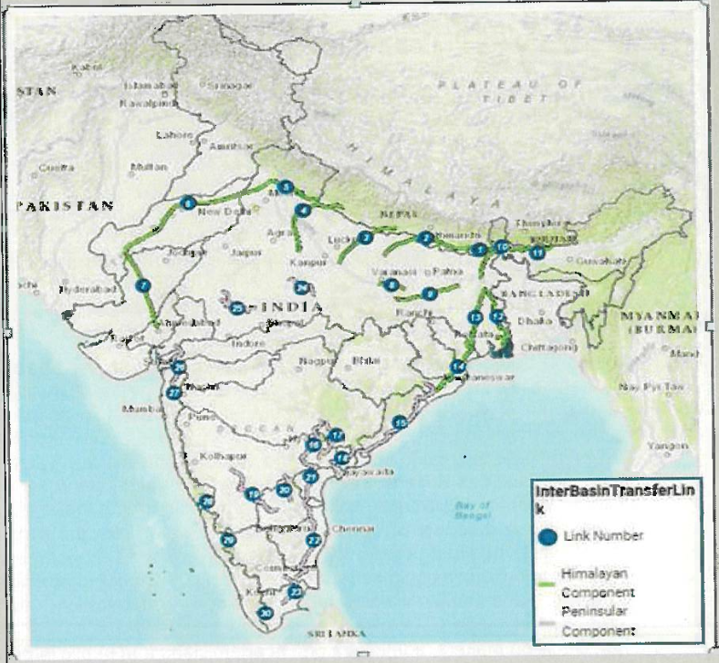

2. Map Of Individual Inter basin Transfer Link — Map Regarding particular Inter Basin Transfer Links.

Fig 2: Map of Damanganga Pinjal Link

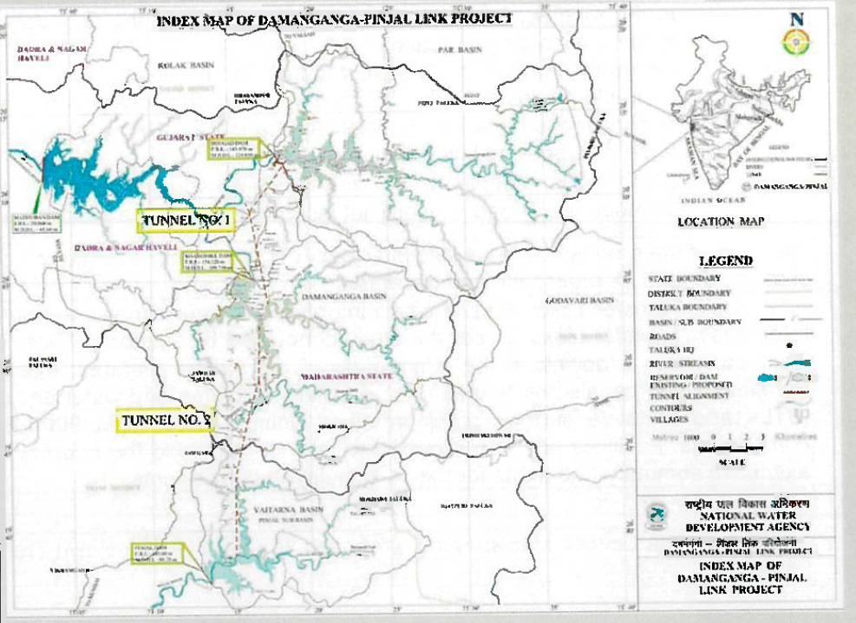

**3.Report for Individual Inter basin Transfer Link :** Report showing salient features of individual Inter Basin Transfer links in tabular format.

**Table- 1: Salient Features of Damanganga Pinjal Link**

|  |  |  |  |  |  |
| --- | --- | --- | --- | --- | --- |
| **1** | **Location** | **Maharashtra and Gujarat** | | | |
| **2** | **Components of Project** | | | | |
| i) | Dam / Reservoir/Barrage | Dams (03 Nos) | | | |
| a) River | Damanganga/Vagh; Vaitarna/Pinjal | | | |
| b) Location | Maharashtra | | Gujarat | |
| c) Submergence Area(ha) | Bhugad Dam | | Khargihill Dam | |
| 1903 | | 1558 | |
| d) Forest land(ha) | Bhugad Reservoir | | Khargihill Reservoir | |
| 290 | | 676 | |
| e) Culturable Land(ha) & (Private land) | 810 | | 612 | |
| f) private land(ha) |  | |  | |
| g) Others land(ha) | 803 | | 270 | |
| h) Population affected (Nos) | 20,501 | | 19273 | |
| i) Village affected partially (no.) Fully | Nil | | Nil | |
| Partially | 14 | | 16 | |
| ii) | Link Canal(RBC/LBC)/Tunnel | | | | |
| a) Length (km) | Tunnel Bhugad-Khargihill reservoir Length=17.488 km | Tunnel connecting-Kharghill-Pinjal reservoir  Length=25.244 km | | |
| b) Location (Passing through: districts) | Bhugad Dam | Kharghill Dam | | |
|  | Thane District | Nasik District | | |
| **3** | **Diversion Quantity(MCM)** | **Bhugad Dam** | **Kharghill Dam** | | **Pinjal Dam** |
|  |  | 210 | 369 | | 316 |
|  |  | Total 895(MCM) | | | |
| **4** | **Benefits From Project** | | | | |
| i) | Irrigation Benefits (ha) | Nil | | | |
| ii) | Hydropower Generation (MU) | Maharashtra | | Gujarat | |
| 16.20 MU | | 9.09 MU | |
| iii) | Power House (MW) | Bhugad Dam | | Kharghill Dam | |
| 2MW | | 3MW | |
| Total | | 5MW(25.29 MU) | |
| iv) | Domestic Water Supply (MCM) | 895 | | | |
| **5** | **States Benefitted** | **Gujarat, Maharashtra** | | | |
| **6** | **Employement Generation (No.)** | The Project affected households and also to each of the major son of such households, besides provision of subsistence allowance,annuity, mandatory employment for one member from each family. | | | |
| **7** | **Total Cost of Project** | (Rupees in Crores) | | | |
| i) | As per DPR(Price Level) | 3008.49 | | | |
| ii) | Projected to Year(2017-18) 5% escalation per annum | 3656.84 | | | |
| **8** | **Annual Cost of the Project** | **(Rupees in Crores)** | | | |
| i) | As per DPR(Price Level) | 407.58 | | | |
| ii) | Projected to Year(2017-18) 5% escalation per annum | 525.79 | | | |
| **9** | **Annual Benefits(in Crores)** | | | | |
| i) | As per DPR(Price Level) | 732.21 | | | |
| ii) | Projected to Year(2017-18) 5% escalation per annum | 890.01 | | | |
| **10** | **Economic Aspect** | | | | |
| i) | Benefit Cost Ratio (BCR) | 1.8 | | | |
| ii) | Internal Rate of Return(IRR) (%) | 14.95 | | | |
| **11** | **Construction Period** | **7 Years** | | | |
| **Source: National Water Development Agency** | | | | | |

**4. Surface profile for Peninsular components of the proposed Inter basin Transfer Link:**

**Fig 3: Elevation/ surface profile of the Damanganga Pinjal Link (Peninsular component)**

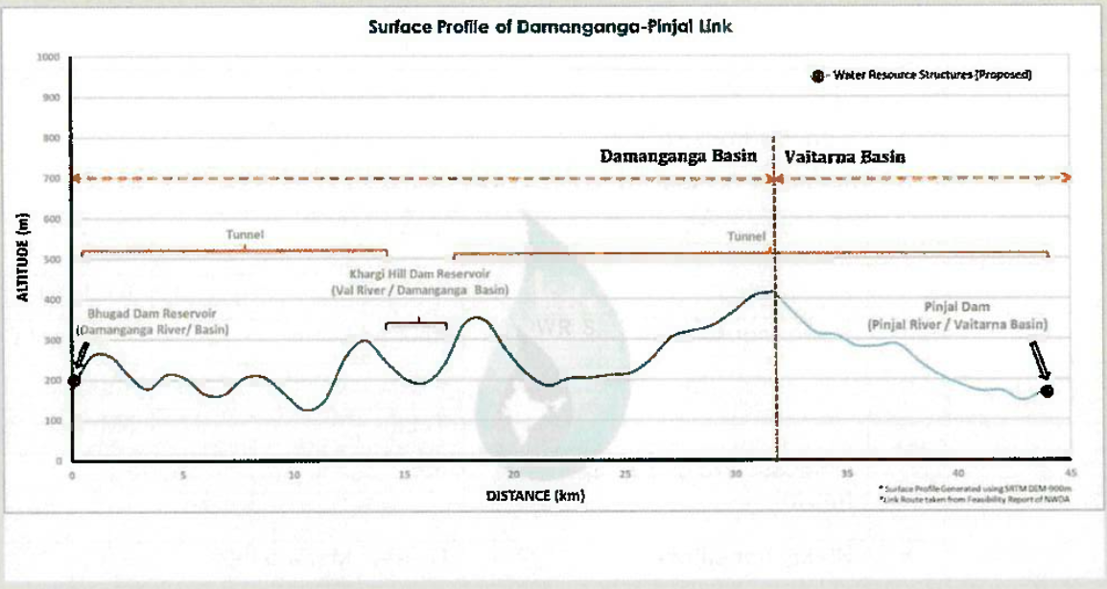

**5. Executive summary of Individual Inter basin Transfer Link :** Executive summary of all the 30 components with compiled information i.e, structures, cost and other information are provided.

**Frequency of Up-dation:-** As per data made available by National Water Development Agency.

**Measure of Success:-** Inter-Basin Transfer Links offers information of the various components of the water transfer links (source: NWDA). In India, rainfall distribution is highly variable both temporally and spatially. Inter basin transfer link proposes river water transfer from the region of surplus to deficit areas. This may provide an effective ways to enhance irrigation potential, to mitigate floods and droughts and reduce regional imbalance by way of additional irrigation, domestic and industrial water supply, hydropower generation, navigational facilities etc.

**Input Data Required:-**

**Data Points:**

|  |  |  |
| --- | --- | --- |
| **Data point** | **Data Type** | **Agency** |
| Administrative Boundary | Polygon | NWIC |
| River Layer | Line | NWIC |
| Major Rivers | Polygon | NWIC |
| Inter basin Transfer links (all 30 links) | Line | NWDA |
| Link ALL (16 Peninsular link in detail) | Line | NWDA |
| Reservoir/ waterbody (associated with IBTL) | Polygon | IWAI/NWDA |
| Structures (Dam/BWA/Lifts) | Point | IWAI/NWDA |

**Process:**

**Algorithm/Tools:-**

National Water Development Agency has provided the detailed data for 16 peninsular components of the Inter Basin Transfer links. The integration of the data from NWDA to ht Inter-Basin Transfer Links module will require following steps.

**Step 1:** Data received from NWDA in hard copy format is first scanned so that further digitization of various datasets can be performed.

**Step 2:** Digitization of components of Inter Basin Transfer links such as —

* **Structures:** name of the structure, type i.e. dam/BWA etc, status i.e. proposed/existing), associated Link name.
* **Reservoir/Waterbody (associated with IBTL):** Name of the Reservoir/waterbody linked with the proposed IBTL along with their status (proposed/ existing) & associated Link name.
* **Link All:** Link Name as well as the detail of each peninsular link i.e. tunnel/ Canal part etc.
* **Inter basin Transfer links:** Containing all the 30 links.

**Step 3:** Topology Correction and data harmonization of digitized data.

**Step 4:** Preparation of map document of Inter Basin Transfer Links data layers along with relevant hydrological layers i.e. Basin, sub basin, major rivers, with label, legends, scale and suitable visibility of layers at varying scales.

**Step 5:** Hosting GIS layers and reports in the Inter-Basin Transfer Links Module. A draft GUI of the IBTL module (from the Inter-Basin Transfer Links module of India-WRIS) can be shown below:

**Fig 4. GUI for Inter-Basin Transfer Links Module**

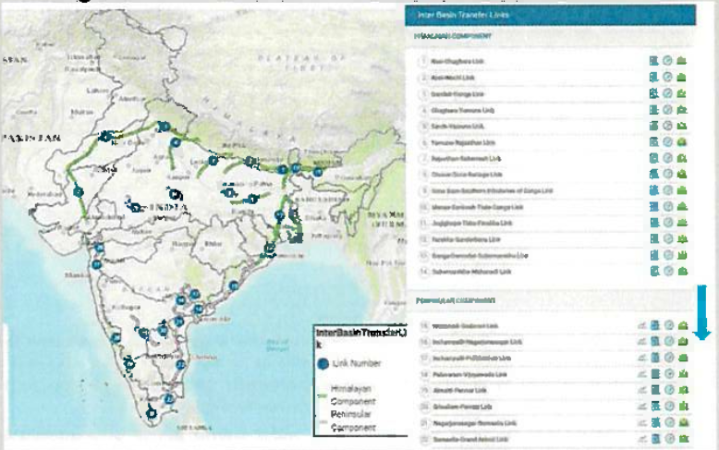

The user may select and view any of the links available in Himalayan and peninsular components from the right side data panel. Reports/ maps i.e.; surface profile (for peninsular component), salient features, executive summery and index map of individual links are provided in the data panel.

**Data Validation:-** Digitization of components of inter basin transfer links from hard copy maps/ survey sheets/toposheets format requires geospatial as well as attribute validation time to time.

**Software Technologies:-**  QGIS Desktop, QGIS Enterprise

**Dependencies & Risks:** Error during data preparation (hardcopy to GIS data creation) i.e. RMSE error, Interpretational erros etc. impacts quality of the processed data. Requirement of data updation based upon the current status (DPR study/ under construction) and data validation by the concerning government agency.

**User Acceptance Testing (UAT):-** NWIC

**Development Responsibility:** NWIC

**References :-**

**1** <https://indiawris.gov.in/wris/#/interbasintransferLink>

2 [www.nwda.gov.in](http://www.nwda.gov.in)

**---End of Document---**